

Tshegofatso Tswai

Prudence Mbiza

PRG(Programming) 252

Assignment 2

# *Project Description*

Belgium Campus has contracted us to create an application that will be responsible for managing student information for the campus. It must be a fully functioning Windows Based application that will capture details of students and details of the modules that the students do and store them in an SQL Relational Database.

Below are the Planning, Use Case diagram and the Uml class diagram that show what we plan on doing in the project.

# *Planning.*

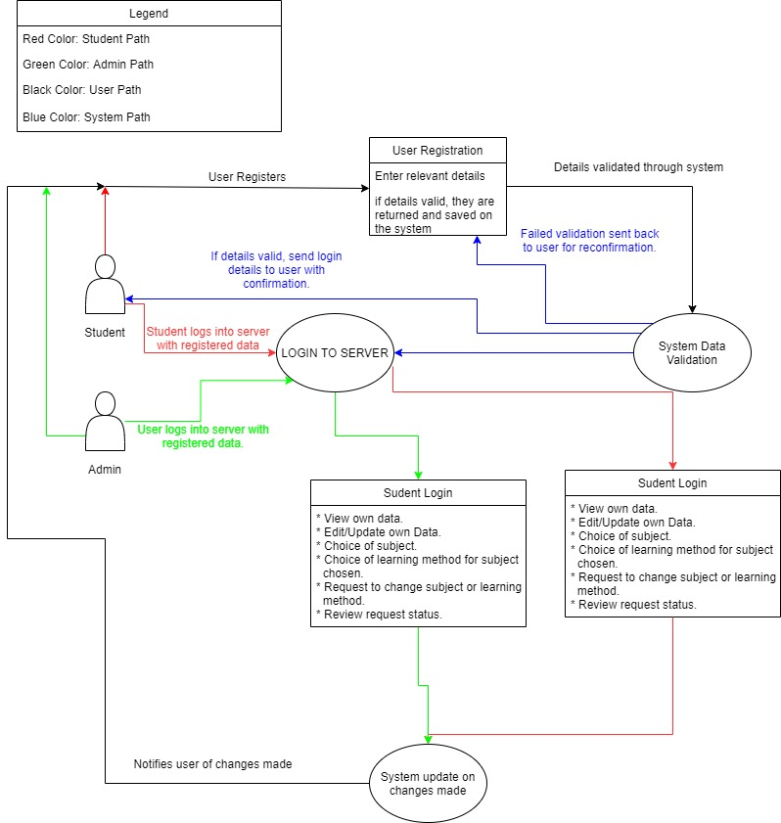

# *Use Case Diagram*

# 

# *Class diagram*

# References

2020 by Visual Paradigm, Visual Paradigm. *UML Class Diagram Tutorial.* [Online]   
Available at: https://www.visual-paradigm.com/guide/uml-unified-modeling-language/uml-class-diagram-tutorial/  
[Accessed 13 June 2021].

2021 Lucid Software Inc., LucidChart. *UML Use Case Diagram Tutorial.* [Online]   
Available at: https://www.lucidchart.com/pages/uml-use-case-diagram  
[Accessed 13 June 2021].

Anon., Lucid. *Blank Diagram.* [Online]   
Available at: https://lucid.app/lucidchart/5b505e5a-9d92-4c58-84b9-f1821b0e0255/edit?page=0_0#  
[Accessed 15 June 2021].